**An Ecohydrological survey of The Moors, Spains Hall Estate, Essex**

**Report for Archie Ruggles-Brise**

**by Mags Cousins (Ecologist) and Dave Gasca-Tucker (Atkins)**

**14th December 2018 (with updates 2020)**

**Introduction**

An ecohydrological survey of the future beaver enclosure at The Moors, within the Spains Hall Estate in Essex was undertaken on 14th December 2018. The proposed enclosure covers a section of a tributary to the Finchingfield Brook and comprises secondary woodland in a small valley with arable land to the north and south.

The survey sought to:

(1) update current hydrological understanding in advance of the release of Eurasian Beaver *Castor fiber* on the site

(2) identify the plant species and describe the communities currently present to establish a baseline prior to beaver introduction and inform the development of a monitoring programme.

Survey results are presented as a series of photographs and annotations and data tables that identify the main hydrological and ecological features observed. A monitoring programme is proposed that will capture changes in the vegetation in response to the action of beavers which are projected to be increased openness (feeding actions - tree felling and grazing) and increased wetness due to construction of small dams leading to braided canals and ponded water which will be created by the beavers to ensure safe feeding areas.

**Method**

A whole site walkover was conducted to compile a vascular plant species list for the proposed beaver enclosure. Plant samples were taken where necessary to confirm identification, particularly for bryophytes (mosses and liverworts). Species identified included planted trees which were widespread in the valley as well as natural regeneration. Broad habitat types were concluded from observations on the day rather than National Vegetation Classification mapping (Rodwell, 1991) as no NVC quadrat data was taken in 2018. The species list and broad habitat types and distribution were used to calculate a representative sample size and method for a future monitoring programme.

Soil litter samples were taken at three locations to determine the terrestrial molluscan fauna and from the main arterial drain and a spring/seepage to determine the aquatic molluscan fauna.

Hydrological features were noted on site such as drains/ditches and seepages and key features in the near catchment such as road and field drains.

Scientific names and vernacular names are given in the Vegetation description section, page 8.

**Results**

**Hydrological features**

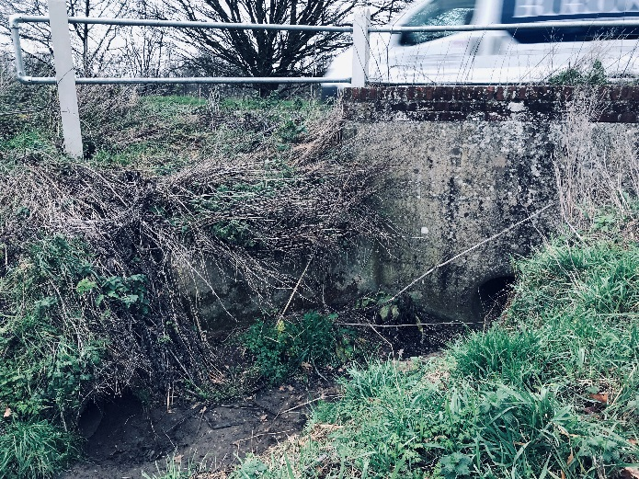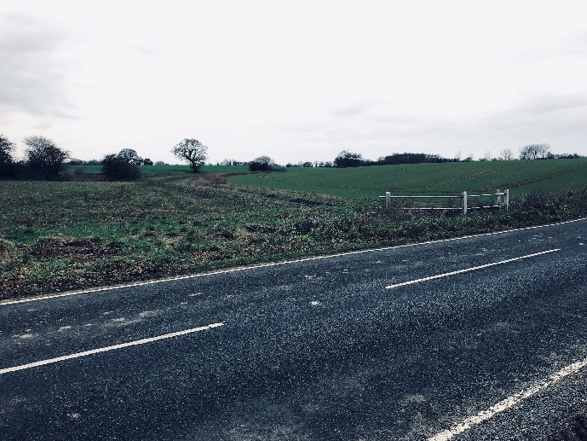

Figure 1. A metalled road (B1053) runs to the south of the future beaver enclosure. A drain from this road (left photograph at TL6786 3292) flows into a small tributary of the beaver enclosure. The catchment of this tributary extends southwards beyond the road, across arable fields (right photograph).

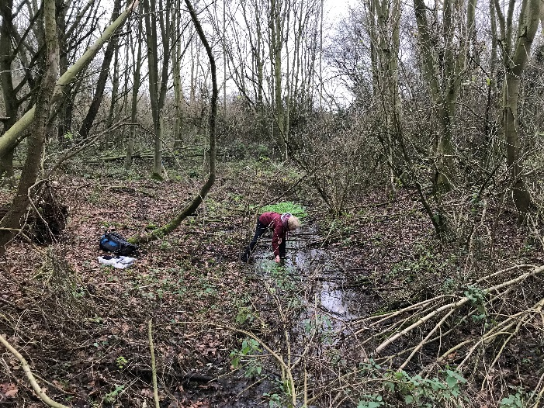 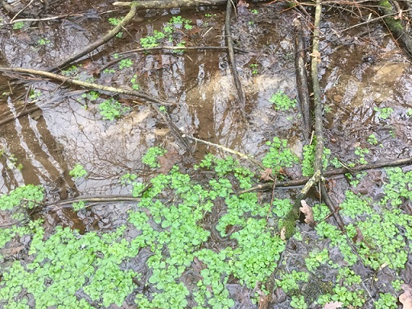

Figure 2. Another water source was a small seep/spring, and/or underdrain outflow (left photograph) located at TL67923 33089, close to the confluence of water courses within the future beaver enclosure. Observed rate of flow was 0.25 – 0.50 litres per second on the day of the survey and had flowed all summer 2018 despite dry conditions (pers comms A. Ruggles-Brise) so the assumption is that at least in part this is a natural spring. At this location, calcium carbonate deposits and a large amount of mollusc shell material was found on the streambed which was sampled (right photograph with Water-cress *Nasturtium officinale*).

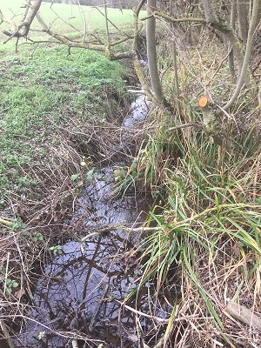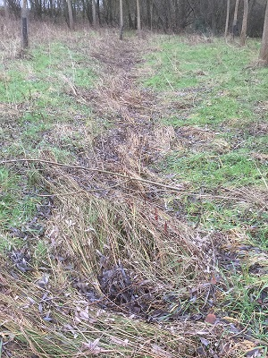

Figure 3. Main arterial drain (left photo), is a straight steep sided channel, photo taken near the south eastern exit point (downstream end) of the beaver enclosure (grid ref TL68072 33035). Right photograph shows one of the feeder drains at the north western (upstream) end of the proposed enclosure (TL67676 33261), currently with no standing water and filled with vegetation, as it passes through the Cricket-bat Willow *Salix alba* var. *caerulea* plantation before connecting with the main arterial drain. Other minor drains were noted in the woodland also connecting with the main drain.

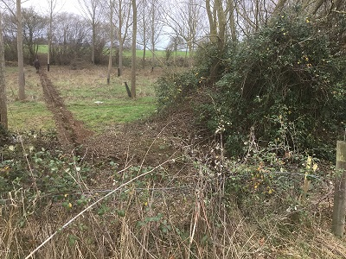

Figure 4. The beaver enclosure spans the narrow valley from cultivated high ground either side (background), across the lower lying central area. Photograph taken at the north western extent with trench dug for the fencing, crossing the Cricket-bat willow plantation.

**Soils profiles**

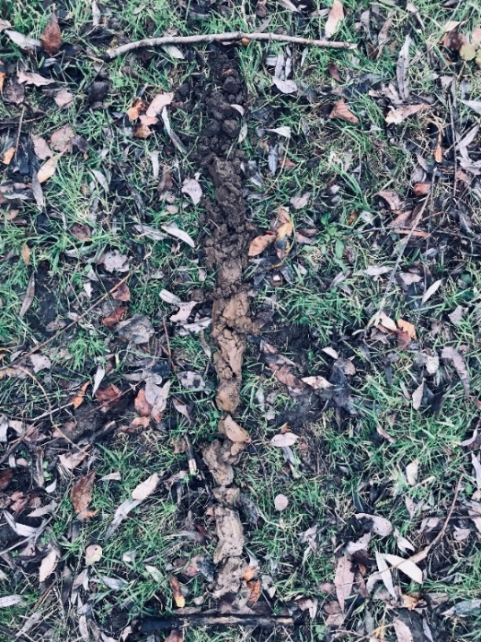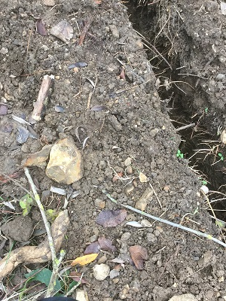

Figure 5. Soil core taken within the future beaver enclosure in the south east, at the downstream end of the enclosure (TL68099 33037). Soils were an inorganic clay loam with flint pebbles grading to silt then gleyed clay with occasional flinty gravels at about 0.8m. Left photograph shows the full core and the right photograph soil thrown up by fence trenching showing flint pebbles. The water table here was 0.6m below ground surface.

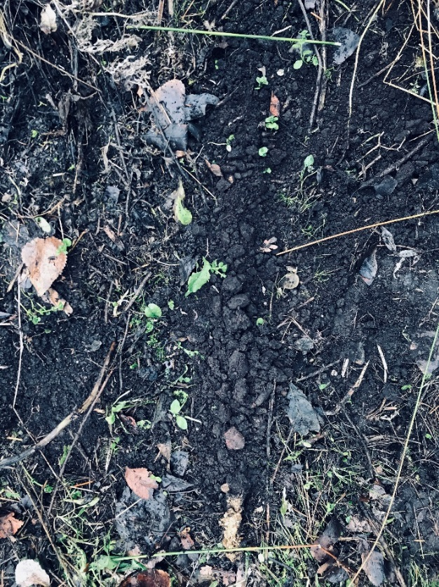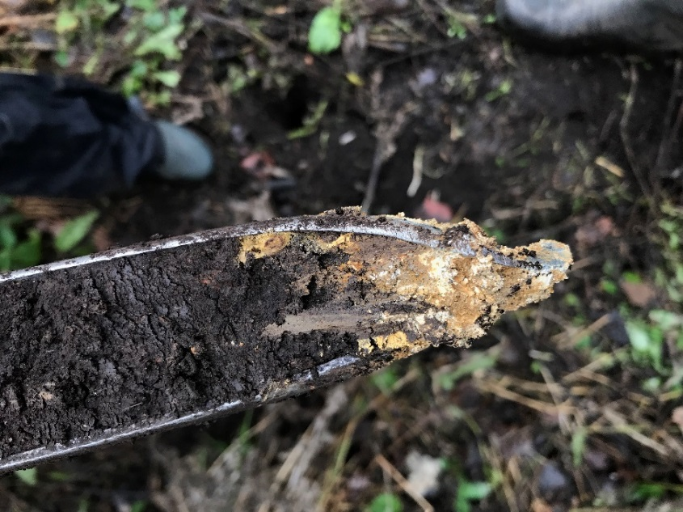

Figure 6. Soil core to the north west at the upstream end of the enclosure (TL67791 33163), soils were highly organic (similar to oxidised peat) formed due to surface ponding and accumulation of organic matter from dead swamp vegetation. This changes abruptly to a silty clay with chalk flints and coarse sand (detail right) at a depth of 0.6m. The water table was not encountered in this core.

**Monitoring equipment and infrastructure**

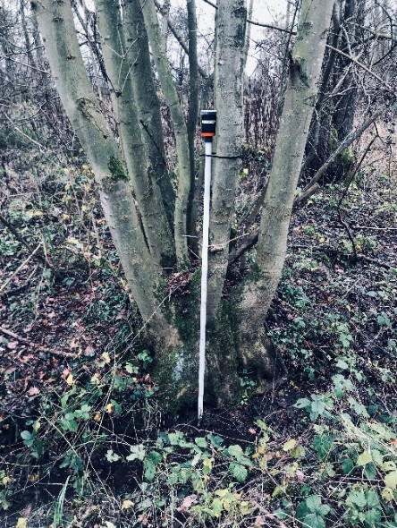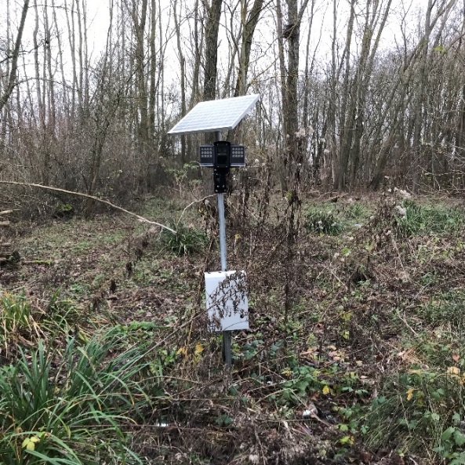

Figure 7. Automatic logging of water levels in the main arterial drain (left photo) is being undertaken within the future beaver enclosure. An automatic camera system (right) is capturing images every hour which will enable time lapse footage to be created.

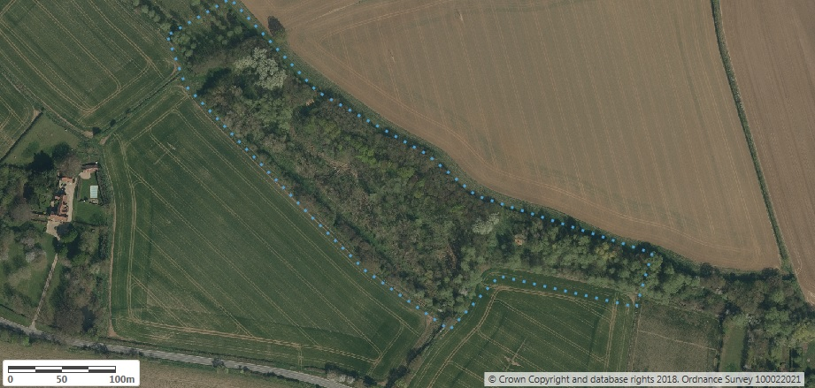

Figure 8. Enclosure fence outline (blue dots)

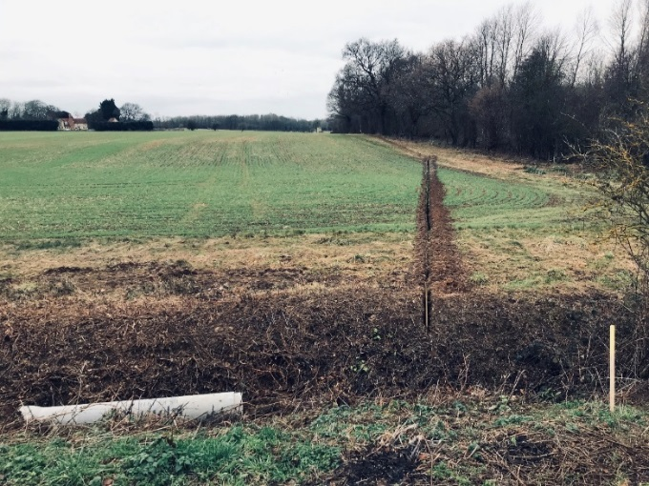

Figure 9. A purpose designed fence will be installed, trenched to a depth of at least 0.3m below ground with gridded concrete culvert pipes on the main arterial drain.

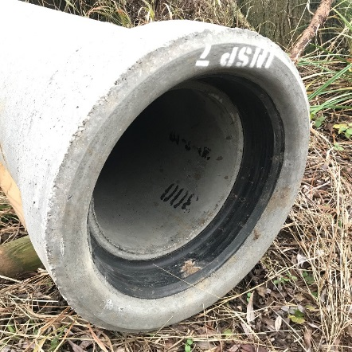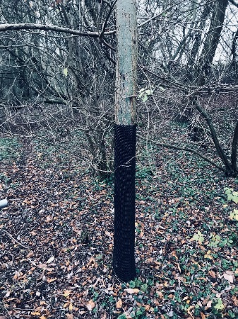

Figure 10. Concrete culvert pipes (left) to be used on the main arterial drain fence and tree protection measures (right) will be deployed on some of the trees within the enclosure.

**Vegetation**

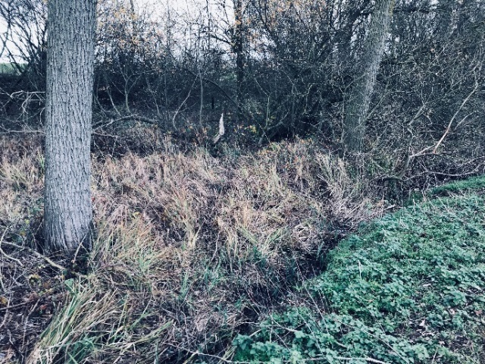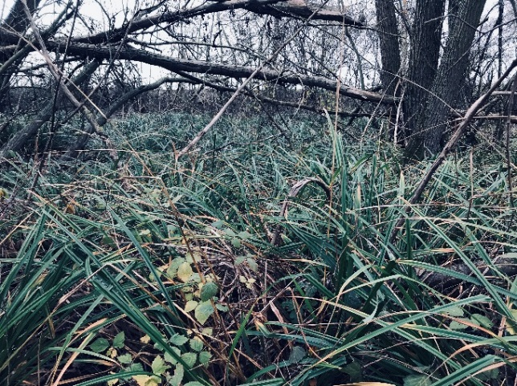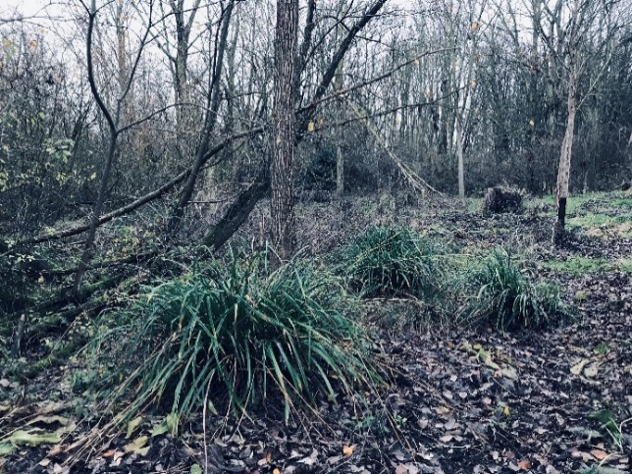

Figure 11. Where the woodland canopy is more open and there is sufficient water supply, a number of species indicative of wetland conditions are present and provide an indication of the vegetation that might expand in range following the introduction of beavers and the wetting up of the site. Top left – bankside fen comprising Lesser Pond-sedge *Carex acutiformis* in a hollow closer to the water table and near to likely winter overspill from the main arterial drain. Top right – larger stand of *C. acutiformis* within open area of damp woodland on organic peat soils over silty clay. Bottom left – Pendulous Sedge *Carex pendula* was frequent in damp woodland.

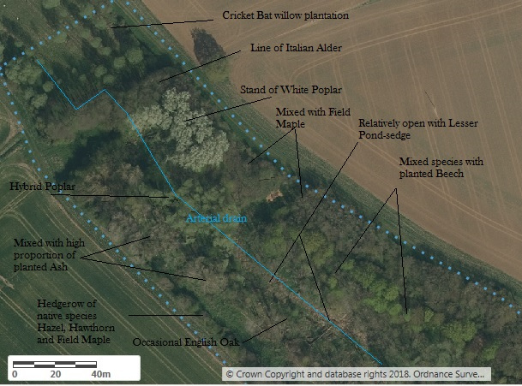

Figure 12. North west end of proposed enclosure - aerial photograph shows the mixture of broadleaved canopy species and the main stand of Lesser Pond-sedge on organic rich soils in a low lying area adjacent to the main arterial drain.

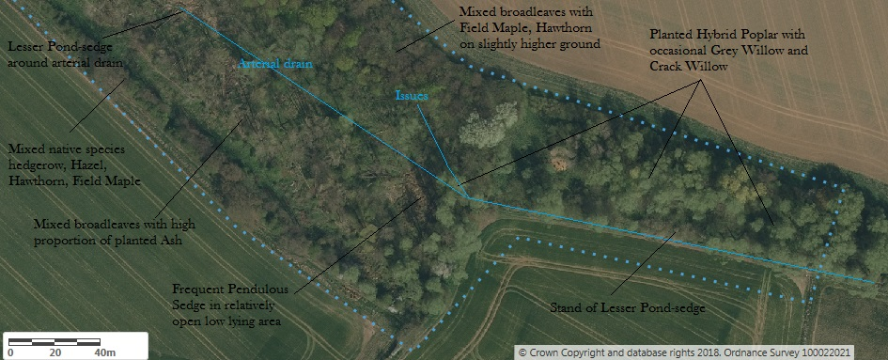

Figure 13. South east end of the proposed enclosure – aerial photograph shows the mix of broadleaved canopy species and another smaller patch of Lesser Pond-sedge adjacent to the drain.

**Vegetation description**

The proposed enclosure is primarily secondary woodland, comprising broadleaves planted into the valley following drainage, with some natural regeneration of native species. There are damp loving species in the central valley area and the lower lying south east such as Hybrid Poplar *Populus* x *canadensis*, some of these now attaining a reasonable size and one supporting Mistletoe *Viscum* *album*. There are also some younger planted Cricket-bat Willow; a stand of White Poplar *Populus alba*, and occasional White Willow *S.alba* and self sown Grey Willow *Salix cinerea* and Aspen *Populus tremula*. On slightly higher ground there is a coupe of planted Ash *Fraxinus excelsior* much of this relatively young approximately 20-30 years and mainly on the south side of the valley, plus Small-leaved *Tilia cordata* and Common Lime *T*. x *europaea*, Beech *Fagus sylvatica* and Pedunculate Oak *Quercus robur*. Some of the Oak is self-sown with natural regeneration of other native species such as Hawthorn *Crataegus monogyna* and Hazel *Corylus avellana* and frequent Field Maple *Acer campestre* and Elder *Sambucus nigra*. There are some coppiced trees which were cut at the time of the most recent felling and replanting, and have regrown. At the time of survey deer browsing pressure is suppressing the growth of natural regeneration of native species.

As the ground rises towards the hedge lines on either side of the narrow valley the proportion of native tree and natural regeneration of species increases. The hedges themselves comprise a mix of sizeable Hazel, Field Maple, Hawthorn, with Blackthorn *Prunus spinosa*, Elm *Ulmus procera*, and occasional Crab Apple *Malus sylvestris* and rarely Spindle *Euonymus europaeus*, the latter shrub species prefers base rich soils. Overall the woodland lacks standing mature and over-mature trees of any species except those in the hedgerows, reflecting the mixed history of the valley, somewhat altered by drainage and planting. The valley has been under woodland management for at least 100 yrs (pers comms Sir Ruggles-Brise) and was cleared and replanted with the mixed broadleaves described above, following the storm of 1987. Cricket-bat Willows have been regularly planted and harvested in the valley at least since the 1950’s. Despite this management there is lying deadwood of various sizes throughout the wood, which will be providing habitat for a variety of wildlife, resulting from forestry operations and from clearance of electric lines.

Damp loving native Willow species *Salix* sp species are infrequent in the proposed beaver enclosure, reflecting the forestry management and the planted trees dominating the canopy. Interestingly there was also a notable lack of colonisation by Sycamore *Acer pseudoplantanus*, the nearest mature seed tree was noted at Dairyley Farm on the edge of a garden and was probably planted. There is no native Common Alder *Alnus glutinosa* in the wood but there was a line of tall planted Italian Alder *A.cordata* at the northern end, this row of trees separating the main wooded area from the main plantation of Cricket-bat Willow.

Beavers will gnaw, fell and eat a range of tree species and the proposal is to protect some trees and not others to observe their feeding preferences. Alder is not favoured by Eurasian Beavers, but Willows and Poplars are actively sought.

The ground flora in the wetter areas comprised some species typical of open fen such as Lesser Pond-sedge, Great Willowherb *Epilobium hirsutum*, Wild Angelica *Angelica sylvestris*, Soft Rush *Juncus effusus*, Marsh Thistle *Cirsium palustre*, Bittersweet *Solanum dulcamara*, Meadowsweet *Filipendula ulmaria*, Hemp Agrimony *Eupatorium cannabinum*, Tufted Hair-grass *Deschampsia cespitosa* and Water Mint *Mentha aquatica*. These damp loving species were most abundant in the more open areas and either adjacent to drains where there would be periodic overspill or in low lying areas near to the underlying water table. Other aquatics included a patch of Fool’s-water-cress *Apium nodiflorum* and nearby a patch of Water-cress *Nasturtium officinale*, a calcicolous species in the stream emanating from the issues where conditions must be quite calcareous (evidenced by calcium carbonate deposits and a large amount of shell debris). The damp woodland supports Pendulous Sedge *Carex pendula* which is regenerating freely but the young plants are being browsed by deer.

Elsewhere Common Nettle *Urtica dioica* and Cleavers *Galium aparine* were abundant where there must be high levels of nutrients but slightly drier conditions (less frequent surface flooding and/or slightly lower water table). On higher ground the woodland ground flora becomes more typical of drier woodland including widespread Red Campion *Silene dioica*, Ground-Ivy *Glechoma hederacea*, Dog’s Mercury *Mercurialis perennis*, Wood False-brome *Brachypodium sylvaticum*, Wood Brome *Bromopsis ramosa*, Hedge Woundwort *Stachys sylvatica*, Greater Stitchwort *Stellaria holostea*, Wood Dock *Rumex sanguineus*, Wood Avens *Geum urbanum* and Bramble *Rubus fruticosus* agg.

The drainage and planting has altered the species composition but the woodland has affinities to two main types under the National Vegetation Classification (Rodwell, 1991). In reality there will be transition between community types and local variation in soils, slope, hydrology and other environmental conditions plus management effects that will affect the type of vegetation present.

The best fit for the drier areas using Kirby’s modified NVC key (Kirby, undated) is W8 *Fraxinus excelsior-Acer campestre-Mercurialis perennis* community Ash-Field Maple-Dog’s Mercury, a frequent but highly variable type of woodland on calcareous mull-humus soils and generally in warmer lower rainfall areas. The ground flora in The Moors is an impoverished form of W8 woodland with few ancient woodland indicators, but Wood Sedge *Carex sylvatica*, was noted in Dec. 2018 and on subsequent visits in 2019, and Moschatel *Adoxa moschatellina,* turned out to be fairly widespread. The canopy species composition is much altered by planting, but the presence of native Hazel and Field Maple in the understorey and Dog’s Mercury, Ground-Ivy, Wood False-brome, Wood Sedge, Cleavers, Wood Avens and Red Campion characterise the vegetation to the W8 woodland community on the upper slopes. The damp areas in places dominated by Common Nettle, Cleavers and frequent Bramble, or Pendulous Sedge and Tufted Hair-grass, can be considered at the damp end of the spectrum for W8, and transitional towards a wet woodland community type.

The wet woodland has affinities to W1 *Salix cinerea-Galium palustre* community, Grey Willow-Marsh Bedstraw woodland despite the low cover of Grey Willow and presence of other tree species such as Hybrid Poplar, due to preferential removal and planting respectively. W1 is a characteristic woodland type on wet mineral soils on the margins of standing or slow-moving water and in moist hollows, mainly in the lowlands. The ground flora of this woodland type can be variable and despite the absence of the community constant Marsh Bedstraw which was not found on this visit, the other species recorded such as Water Mint, Wild Angelica, Meadowsweet and Soft Rush are characteristic.

The stands of Lesser Pond-sedge found here in The Moors are less often associated with this fen woodland type. The largest stand of the sedge was on the more organic rich soils. Lesser Pond-sedge stands can occur as a dominant species in open conditions, the swamp community (NVC type S7 *Carex acutiformis* Lesser Pond-sedge swamp) and the patches currently found in The Moors could be where the sedge has persisted from earlier open and wetter conditions. Now they are in reality a component of the fen woodland due to the proportion of trees and the presence of species less tolerant of prolonged deep water such as Soft Rush. This could shift again in favour of Lesser Pond-sedge if water depth and light increases. Overhead power lines are kept clear of tall trees and this increased light has enabled Welted Thistle *Carduus crispus*, Cleavers and thickets of Bramble to develop, with natural regeneration of native shrubs including Elm and Field Maple which are heavily browsed by deer.

A few common woodland bryophytes (mosses and liverworts) were recorded on the lower parts of tree trunks, on fallen wood and amongst the leaf litter: Hart's Tongue Thyme-moss *Plagiomnium undulatum*; Common Feather-moss *Kindbergia praelonga* and Rough-stalked Feather-moss *Brachythecium rutabulum*, Bryophytes were not sampled thoroughly on this visit, so more species are likely to be present, but it was notable that bryophytes did not form a significant component of the flora.

|  |  |
| --- | --- |
| **Plants** | |
| **Species name** | **English name** |
| *Acer campestre* | Field Maple |
| *Alnus cordata* | Italian Alder |
| *Angelica sylvestris* | Wild Angelica |
| *Anthriscus sylvestris* | Cow Parsley |
| *Apium nodiflorum* | Fool's Water-cress |
| *Betula pendula* | Silver Birch |
| *Bromopsis ramosa* | Hairy (Wood) Brome |
| *Carduus crispus* | Welted Thistle |
| *Carex acutiformis* | Lesser Pond-sedge |
| *Carex hirta* | Hairy Sedge |
| *Carex pendula* | Pendulous Sedge |
| *Carex sylvatica* | Wood Sedge |
| *Cirsium arvense* | Creeping Thistle |
| *Cirsium palustre* | Marsh Thistle |
| *Corylus avellana* | Hazel |
| *Crataegus monogyna* | Hawthorn |
| *Dactylis glomerata* | Cock's-foot Grass |
| *Deschampsia cespitosa* | Tufted Hair-grass |
| *Brachypodium sylvaticum* | Wood False-Brome |
| *Epilobium hirsutum* | Great Willowherb |
| *Euonymus europaeus* | Spindle |
| *Eupatorium cannabinum* | Hemp Agrimony |
| *Fagus sylvatica* | Beech |
| *Filipendula ulmaria* | Meadowsweet |
| *Fraxinus excelsior* | Ash |
| *Galium aparine* | Cleavers |
| *Geranium molle* | Dove's-foot Crane's-bill |
| *Geum urbanum* | Wood Avens |
| *Glechoma hederacea* | Ground-Ivy |
| *Hedera helix agg* | Ivy |
| *Heracleum sphondylium* | Hogweed |
| *Holcus lanatus* | Yorkshire Fog |
| *Juncus conglomeratus* | Conglomerate Rush |
| *Juncus effusus* | Soft Rush |
| *Juncus inflexus* | Hard Rush |
| *Lamium album* | White Dead-nettle |
| *Lapsana communis* | Nipplewort |
| *Mentha aquatica* | Water Mint |
| *Mercurialis perennis* | Dog's Mercury |
| *Nasturtium officinale* | Water-cress |
| *Populus alba* | White Poplar |
| *Populus x canadensis* | Hybrid Poplar |
| *Populus tremula* | Aspen |
| *Malus sylvestris* | Crab Apple |
| *Prunus spinosa* | Blackthorn |
| *Quercus robur* | Pedunculate Oak |
| *Ranunculus repens* | Creeping Buttercup |
| *Rubus fruticosus agg.* | Bramble |
| *Rubus caesius* | Dewberry |
| *Rumex sanguineus* | Wood Dock |
| *Salix alba var. caerulea* | Cricket-bat Willow |
| *Salix cinerea* | Grey Willow |
| *Salix alba* | White Willow |
| *Sambucus nigra* | Elder |
| *Silene dioica* | Red Campion |
| *Solanum dulcamara* | Bittersweet |
| *Stachys sylvatica* | Hedge Woundwort |
| *Stellaria holostea* | Greater Stitchwort |
| *Symphytum officinale* | Comfrey |
| *Tilia cordata* | Small-leaved Lime |
| *Tilia x europaea* | Common Lime |
| *Ulmus procera* | English Elm |
| *Urtica dioica* | Common Nettle |
| *Viscum album* | Mistletoe |
| *Plagiomnium undulatum* | Hart's Tongue Thyme-moss |
| *Kindbergia praelonga* | Common Feather-moss |
| *Brachythecium rutabulum* | Rough-stalked Feather-moss |

Table 1. Plant species recorded on 14/12/18.

**Molluscan fauna**

Only two species of aquatic molluscs were found; a pea mussel *Euglesa personata*, in both the arterial drain and in the seep/spring; and Dwarf Pond Snail *Galba truncatula*, only one freshly dead shell and found only in the seep. Both of these species can tolerate periods of drying and the Dwarf Pond Snail does spend a proportion of time out of water in very damp marsh vegetation. Both watercourses were calcareous with calcium carbonate deposits but provide limited niches for aquatic molluscs there being little aquatic and emergent vegetation, and large fluctuations in water supply with periodic low water levels or complete drying, changing to high flow flood conditions after heavy rainfall.

The shell debris from the spring/seepage was interesting in that it comprised largely dryland/terrestrial species which included very worn shells of species of more open dry calcareous grassland such as Moss chrysalis snail *Pupilla muscorum* and Wrinkled snail *Xeroplexa intersecta*, which had probably been washed out of the soil layers and dating from a time when the adjacent habitat was more open, permanent grassland, prior to arable intensification. Also found were worn shells of Common whorl snail *Vertigo pygmaea*; Marsh whorl snail *Vertigo antivertigo* and Prickly snail *Acanthinula aculeata*. There is a chance that these species could persist in the damp vegetation of the more open areas of the woodland, as they are known to frequent open damp grassland and marshy vegetation, although no live specimens were found elsewhere on this survey visit.

Terrestrial molluscan species were sampled at two locations:

1) Woodland leaf litter by searching under lying deadwood plus taking a small bag for drying and lab analysis for the smaller species. Here a limited range of very widespread species were found such as Smooth glass snail *Aegopinella nitidula* and Strawberry snail *Trochulus striolatus*. There were no ancient woodland indicator species and the fauna somewhat limited probably due to the recent nature of the woodland, although more thorough searching would almost certainly reveal more species on this base rich site with plentiful calcium for shell building.

2) The mollusc fauna was also sampled in both stands of Lesser Pond-sedge and a range of species typical of both woodland Common or Two-toothed door snail *Clausilia bidentata* *bidentata* and species of marsh and damp grassland were found, such as Large amber snail *Succinea putris*; Tawny glass snail *Euconulus fulvus* and Slippery moss snail *Cochlicopa* cf. *lubrica*. The most notable find were several live Three-toothed moss snail *Azeca goodalli* which is a local species, colonies being small and sharply defined, preferring light shade, avoiding extremes of open ground or dense shade and usually found in calcareous places. The snail species were at all at low abundance but the areas of habitat were very localised.

A total of 23 different species of mollusc were found, although six of these were found only as dead shells, so whether they persist in the enclosure is uncertain at this stage.

|  |  |
| --- | --- |
| **Molluscs** | |
| **Species name** | **Common name** |
| *Acanthinula aculeata* | Prickly snail |
| *Aegopinella nitidula* | Smooth glass snail |
| *Aegopinella pura* | Clear (delicate) glass snail |
| *Azeca goodalli* | Three-toothed moss snail |
| *Carychium minimum* | Herald snail |
| *Cepaea hortensis* | White-lipped snail |
| *Clausilia bidentata bidentata* | Common (or two-toothed) door snail |
| *Cochlicopa cf. lubrica* | Slippery moss snail |
| *Columella edentula* | Toothless chrysalis snail |
| *Discus rotundatus* | Rounded snail |
| *Euglesa personata* | a pea mussel (unconfirmed) |
| *Euconulus fulvus* | Tawny Glass snail |
| *Galba truncatula* | Dwarf pond snail |
| *Pupilla muscorum* | Moss chrysalis snail |
| *Succinea putris* | Amber snail |
| *Trochulus hispidus* | Hairy Snail |
| *Trochulus striolatus* | Strawberry snail |
| *Vallonia pulchella* | Smooth grass snail |
| *Vertigo antivertigo* | Marsh whorl snail |
| *Vertigo pygmaea* | Common whorl snail |
| *Vitrea crystallina* | Crystal snail |
| *Vitrina pellucida* | Pellucid glass snail |
| *Xeroplexa intersecta* | Wrinkled snail |
|  |  |
| **Other invertebrates** | |
| *Chthonius ischnocheles* | Common Chthonid pseudoscorpion |
|  |  |

Table 2. Mollusc and other invertebrate species list recorded on 14/12/18

**Discussion**

The soil cores correspond to the classification of Ludford Association Deep Loams which are derived from Glaciofluvial drift (Landis UK, Soilscapes Classification, Cranfield University 2018). The description for the soils in this series is a mixed picture being from fine to coarse loamy and sandy, locally flinty and in places over gravel. The brown earths can be mixed with the surface Plateau drift and underlying clayey chalky till and London Clay and river terrace deposits. At The Moors in these two cores the underlying clay and silts give rise to impeded drainage and this is reflected in the vegetation with species tolerant of damp to wet conditions being locally frequent in both the shrub layer *Salix cinerea*, Grey Willow and the ground flora for example Lesser Pond-sedge *Carex acutiformis* and Pendulous Sedge *Carex pendula*. The calcareous influence of the underlying chalky till also manifests in the calcium carbonate deposits and quantity of shell debris in the water courses and the presence of calcicoles (lime loving) in the vegetation, such as Water-cress *Nasturtium officinale.*

The creation, or at least straightening and deepening of the main arterial drainage channel has constrained wetland vegetation to lower lying areas closer to the water table or more prone to winter flooding from overspill from the ditch. Prior to historic human interference the water would have progressed as diffuse overland flow, or if water levels were high enough with sufficient energy would have followed a more sinuous path along the valley bottom, with fluvialgeomorphological processes creating small meanders with debris dams, ponding and other features in a dynamic state. It is expected that beavers will create braided channels and a network of pooled water and the heterogeneity of the valley wetland will again increase. The main arterial drain will likely be a target for modification by beavers as it represents the main water supply and the means by which they can create safe access to their preferred feeding areas (water filled canals deep enough to swim away from danger). It is quite possible that the beavers will also exploit the remnant cross drains that connect with the main arterial drain and also the spring/seepage to create water filled access canals to favoured food supplies.

There is likely to be increasing heterogeneity in the woodland canopy as favoured feeding trees are felled by beavers to access small branches and to create by coppicing, more nutritious young growth but this will vary between tree species. Beavers have a broad diet but it is known that they don’t tend to feed on Alders so the row of Italian Alders are likely to remain intact. Other trees will be protected from the beavers deliberately. There will be death of some trees due to waterlogging, species such as Lime *Tilia* sp., Beech *Fagus sylvatica*, Hawthorn *Crataegus monogyna* and Hazel *Corylus avellana* will not be able to withstand prolonged periods with their roots submerged. The coupe of planted Ash *Fraxinus excelsior* was not inspected for Ash Dieback *Chalara fraxinae* but this is quite likely to affect the trees in the future as this disease spreads, so death of Ash is also to be expected.

Overall there will be a change in proportion of dry and wet species in ground flora and natural regeneration of woody species and a monitoring programme is proposed to detect such changes. There is also likely to be a shift in the species composition of the molluscan fauna to include more semi aquatic and aquatic species and species of open marshy vegetation and it will be interesting to see how quickly this occurs.

**Proposed Monitoring Programme**

Two vegetation survey transects with quadrats spaced along them were provisionally established by a consortium of partners (see [Spains Hall Story Map](https://arcg.is/0H1Si4)) but these will be hard to replicate in future due to lack of precision about placement of the quadrats at the time, but also the terrain, as following the transects across the valley could become increasingly difficult due to the activities of the beavers (fallen trees and raised water levels).

A more practicable option is a regular grid of quadrats, providing good coverage of the site and encompassing the vegetation variation in terms of species composition, relative abundance and distribution. Sufficient quadrats can be selected for monitoring within the enclosure, accepting that increasing wetness and fallen trees due to beaver activity may render more and more of the site inaccessible for future monitoring of vegetation by the traditional means of surveyor visits on foot.

The species data can be portrayed using Ellenberg's indicator values (Hill, 2004), which are based on a simple ordinal classification of plants according to the position of their ecological niche along an environmental gradient. This can then be portrayed as 3-dimensional graphics showing how species, wetness, light and other factors alters over time and space within the beaver enclosure.

Mollusca monitoring can be done by sampling at the same quadrat locations, collecting a small bag of leaf litter, hand searching to a standardised time and sieving if standing water is present.

**References**

Hill, M.O., Preston, C.D. & Roy, D.B. 2004 PLANTATT, Attributes of British and Irish Plants: Status, Size, Life History, Geography and Habitats, Biological Records Centre, NERC Centre for Ecology and Hydrology.

Rodwell, J.S. 1991 British Plant Communities Volume 1 Woodlands and Scrub, Nature Conservancy Council, Cambridge University Press.

Rodwell, J.S. 1995 British Plant Communities Volume 4 Aquatic communities, swamps and tall-herb fens, Nature Conservancy Council, Cambridge University Press.